# Project Design Phase-II Technology Stack (Architecture & Stack)

|  |  |
| --- | --- |
| Date | 19 October 2022 |
| Team ID | IBMSI20220041672 |
| Project Name | Project - IoT Based Safety Gadget For Child Safety Monitoring & Notification |
| Maximum Marks | 4 Marks |
|  |  |

**Technical Architecture:**

The Deliverable shall include the architectural diagram as below and the information as per the table1 & table 2

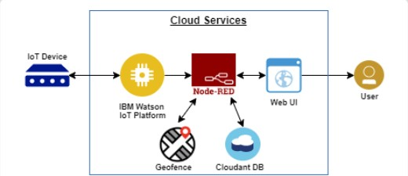

Guidelines:

1. Include all the processes (As an application logic / Technology Block)
2. Provide infrastructural demarcation (Local / Cloud)
3. Indicate external interfaces (third party API’s etc.)
4. Indicate Data Storage components / services
5. Indicate interface to machine learning models (if applicable)

# Table-1 : Components & Technologies:

|  |  |  |  |
| --- | --- | --- | --- |
| **S.No** | **Component** | **Description** | **Technology** |
| 1. | User Interface | Web UI, Node-RED, MIT app | IBM IoT Platform, IBM Node red, IBMCloud |
| 2. | Application Logic-1 | Create IBM Watson IoT platform and create node-red service | IBM Watson, IBM cloud service ,IBM node-red |
| 3. | Application Logic-2 | Develop python script to publish and subscribe to IBM IoT  Platform | python |
| 4. | Application Logic-3 | Build a web application using node-red service | IBM Node-red |
| 5. | Database | Data Type, Configurations etc. | MySQL |
| 6. | Cloud Database | Database Service on Cloud | IBM Cloudant |
| 7. | File Storage | Developing mobile application to store and receivethe sensors | Web UI ,Python |

|  |  |  |  |
| --- | --- | --- | --- |
|  |  | information and to react accordingly |  |
| 8. | External API-1 | Using this IBM child monitoring API we can track the location of the place of child and where the  child had been leaved the geofence area. | IBM Weather API, etc. |
| 9. | External API-2 | Using this IBM Sensors it detects the child activity, temperature and provides the information to the parents or caretaker through web  UI | Aadhar API, etc. |
| 10. | Machine Learning Model | Using this we can derive the object recognition model | Object Recognition Model, etc. |
| 11. | Infrastructure (Server / Cloud) | Application Deployment on Local System / Cloud Server Configuration | IBM cloudant, IBM IoT Platform |

**Table-2: Application Characteristics:**

|  |  |  |  |
| --- | --- | --- | --- |
| **S.No** | **Characteristics** | **Description** | **Technology** |
| 1. | Open-Source Frameworks | MIT app Inventor | MIT License |
| 2. | Security Implementations | IBM Services | Encryptions, IBM Controls |
| 3. | Scalable Architecture | sensor-IoT Cloud based  architecture | Technology used |
| 4. | Availability | Mobile, laptop, desktop | MIT app |
| 5. | Performance | checking the child's location notifications will be generated if the child crosses the geofence.  Notifications will be sent according to the child's location to their parents or caretakers. The  entire location data will be stored in the database. | Temparature sensor |